

# Case Study III

## Context-aware summarization of educational texts using knowledge graphs

G-Drive Link project demo:

[drive,google.com/nlp-project](https://drive.google.com/file/d/1GM22karaiQ8nthNGVfazk6aRTpVO49zT/view?usp=drive_link)

GitHub Repo link:

[github.com/MehulSingh08/nlp-summarizer](https://github.com/MehulSingh08/nlp-summarizer)

**Team Details Submitted to:**

Mehul Singh 22BCE2455 Prof. Rajeshkannan R

Kalpak Patil 22BCE2418

Siddhant Vyas 22BCE2023

**1. Abstract**

The exponential growth of digital educational content has led to severe information overload, hindering efficient knowledge consumption for students and researchers. To address this challenge, this project focuses on developing a hybrid, full-stack text summarization system.

The core research gap lies in the absence of user-oriented tools that integrate both transparent extractive and fluent abstractive summarization options.

Our methodology combines two NLP approaches: (1) a graph-based TextRank algorithm implemented using **NetworkX**, computing sentence importance through **PageRank** and visualized interactively via **vis.js**; and (2) a **T5 (t5-small)** transformer model fine-tuned on the **arXiv** dataset for domain-specific abstractive summarization. Both models are deployed via a **Flask API** with a **Streamlit** interface for seamless user interaction.

Experimental results demonstrate that the system effectively produces two complementary summaries, a detailed extractive version emphasizing key sentences and a concise, generative abstractive version maintaining semantic coherence. This dual-mode system offers a practical and adaptable tool for learners and researchers to navigate and synthesize large volumes of textual data efficiently.

# **2. Introduction**

**Background and Relevance**

The digital era provides unprecedented access to educational resources, but this has also led to critical information overload. Students and researchers are confronted with vast amounts of text, making it difficult to extract essential concepts efficiently. This necessitates advanced NLP tools to intelligently condense content, not just for brevity, but for enhanced comprehension.

**Review of Existing Solutions and Limitations**

Existing solutions are broadly categorized into two types:

1. **Extractive Summarization:** These methods select the most important sentences from the original text (e.g., TextRank). While fast and factually consistent, the resulting summaries can be disjointed, choppy, and lack the logical flow of the original argument.
2. **Abstractive Summarization:** These methods generate new, novel sentences, much like a human would. Modern approaches use advanced Transformers (e.g., T5, BART). While fluent, these models can "hallucinate", generating factually incorrect text, which is unacceptable in an educational setting.

**Research Gap**

A significant gap exists in providing a single, user-friendly tool that bridges these two approaches. Users often lack the choice between a quick, factual summary (extractive) and a fluent, generative one (abstractive). Furthermore, most extractive tools are "black boxes," not showing *why* a sentence was deemed important. This project addresses this gap by:

1. Offering a **hybrid model** with user-selectable methods.
2. Providing an **interactive graph visualization** for the extractive method, adding transparency.
3. **Fine-tuning** the abstractive model on academic text (the arXiv dataset) to improve its accuracy for educational content.

**Objective and Proposed Solution**

The objective is to design and implement a hybrid educational text summarizer that provides users with both extractive and abstractive capabilities, complete with a transparent visualization component.

Our proposed solution is a full-stack web application:

1. **Backend:** A Flask API (backend/app.py) serves two summarization models.
   * **Extractive Model:** An implementation of the **TextRank** algorithm (backend/model.py). It builds a sentence-similarity graph using networkx, applies PageRank to score sentences, and generates graph data.
   * **Abstractive Model:** A **T5 (t5-small) transformer model** (backend/model.py). This model is fine-tuned on the arxiv_data.csv dataset (using abstracts as input and titles as target summaries) to specialize it for academic text.
2. **Frontend:** A Streamlit web interface (frontend/app.py) allows users to paste text, choose their desired method, and view the results, including an interactive vis.js knowledge graph for the extractive method.

**Major Contributions**

The major contributions of this project are:

1. **Hybrid Model Implementation:** Successful integration of two distinct NLP summarization techniques (graph-based TextRank and transformer-based T5) into a single, cohesive application.
2. **Interactive Knowledge Graph:** Development of a novel visualization for the TextRank algorithm, rendering the sentence similarity matrix as an interactive graph in the UI. This provides transparency, allowing users to visually explore sentence relationships and importance.
3. **Domain-Specific Fine-Tuning:** A complete pipeline for fine-tuning the T5 model on the arxiv_data.csv dataset, adapting the generative model to the specific vocabulary and structure of educational texts.
4. **Full-Stack Application:** The creation of a robust, end-to-end system with a decoupled Flask backend API and an intuitive Streamlit frontend, demonstrating a practical application of advanced NLP models.

# **3. Literature Survey**

This project builds upon established research in graph-based extractive summarization and transformer-based abstractive summarization, while specifically addressing gaps related to educational texts, explainability, and knowledge integration using recent advancements highlighted in IEEE publications.

**Overview of Traditional and Recent Methods**

Traditional extractive methods like TextRank (Mihalcea & Tarau, 2004) adapted graph algorithms for sentence ranking. Abstractive methods saw significant progress with sequence-to-sequence models and later, the Transformer architecture (Vaswani et al., 2017), leading to powerful models like T5 (Raffel et al., 2020) capable of generating fluent, human-like text.

Recent research, particularly within IEEE forums, focuses on **hybrid approaches** and **knowledge enhancement** to overcome the limitations of purely extractive or abstractive methods, especially for specialized domains like scientific and educational texts. Graph Neural Networks (GNNs) combined with Transformers are increasingly explored. For instance, **Xie et al. (2023)** developed a **knowledge-enhanced graph topic transformer** for biomedical texts, integrating domain knowledge (from UMLS) and GNNs into a transformer model to improve both accuracy and explainability. Similarly, **Özçelik & Cicekli (2024)** proposed a **Graph-Based Abstractive Summarization (GBAS)** model using SciBERT and a **Graph Transformer Network (GTN)** specifically for summarizing long scientific articles, leveraging graph structures to maintain document integrity.

**Comparative Analysis**

Comparing recent works reveals key trends:

1. **Hybrid Models for Scientific Text:** The focus on scientific and technical documents is evident. **Özçelik & Cicekli (2024)** directly tackle the challenges of summarizing long scientific articles using a hybrid graph-transformer approach. This aligns with our project's goal of handling educational (often technical) content.
2. **Knowledge Integration and Explainability:** Injecting structured knowledge and providing transparency are crucial. **Xie et al. (2023)** emphasize explainability by integrating graph topic models and domain knowledge, allowing users to understand *why* sentences are chosen. This resonates with our project's use of an interactive graph for the TextRank output.
3. **Evaluation Beyond ROUGE:** There's a growing recognition that standard metrics are insufficient. **Armano et al. (2024)** explore summarizing knowledge graphs themselves using semantic maps, implicitly addressing the need for better ways to represent and understand graph-based knowledge beyond simple text output.
4. **Contextualizing LLMs:** The broader landscape of LLMs and generative AI is rapidly evolving, as surveyed by **Hagos et al. (2024)**. Their work highlights the capabilities and challenges of models like T5 in various applications, including summarization, providing essential context for our abstractive component.
5. **Human-Centered AI in Education:** The application of AI in education requires careful consideration of human factors. **Bervell et al. (2025)** provide a systematic review focusing on **Human-Centered AI (HCAI)** in higher education, stressing the importance of ethics, transparency, and balancing automation with human expertise. This reinforces the need for explainable and reliable AI tools in educational settings.

**Identification of Limitations and Research Gap**

Based on the literature, including recent IEEE publications:

1. **Domain Specificity:** While models like GBAS and DORIS target scientific/biomedical domains, there's still a need for robust testing and adaptation specifically for broader *educational* texts across various subjects.
2. **Explainability Integration:** Though works like Xie et al. (2023) focus on explainability, integrating user-friendly, interactive explanations (like our graph visualization) directly into hybrid summarization tools remains an area for improvement.
3. **Evaluation Metrics:** The field still grapples with evaluating summaries, especially knowledge-enhanced ones, beyond ROUGE. While Armano et al. (2024) work on KG summarization itself, evaluating the *pedagogical effectiveness* of text summaries generated *with* KG insights needs better metrics.
4. **Human-Centered Design:** As highlighted by Bervell et al. (2025), applying HCAI principles systematically in the design and deployment of educational AI tools like summarizers requires further research and practical frameworks.

This project addresses these gaps by creating a hybrid tool specifically demonstrated on educational text, incorporating a visual explainability component (the interactive graph), and implicitly acknowledging the need for human-centered design through user choice and transparency.

|  |  |  |  |  |
| --- | --- | --- | --- | --- |
| **S.No** | **Title of the Paper and Author(s), Year** | **Methodology/ Approach & Dataset** | **Key Findings / Contributions** | **Limitations / Gaps** |
| 1 | Enhancing abstractive summarization with extracted knowledge graphs and multi-source transformers. Chen, T. et al. (2023) | Approach: Hybrid model (MultiBART-GAT) using BART for text and GAT for an extracted KG. Dataset: CNN/DailyMail, XSum. | Findings: Injecting KG information into a Transformer decoder improves summary quality and factuality. Contributions: Strong architectural blueprint for hybrid text-graph summarization. | Not tested on educational texts; KGC is a separate preliminary step. |
| 2 | Fact-aware generative text summarization with dependency graphs. Chen, R. et al. (2024) | Approach: Dual-encoder system processing text (Transformer) and a dependency graph (Relational GAT). Dataset: CNN/DailyMail. | Findings: Incorporating grammatical structure reduces factual inconsistencies. Contributions: Powerful technique for improving summary faithfulness. | Focuses on grammatical structure, not broader semantic knowledge; not tested in an educational context. |
| 3 | Graph embedding-based domain-specific knowledge graph expansion using research literature summary. Choi, J. (2022) | Approach: Uses summarization (BERTSUM) to condense literature, then applies relation extraction to expand a domain KG. Dataset: CORD-19. | Findings: Summarization is an effective pre-processing step for more accurate KGC. Contributions: Reveals a symbiotic relationship between summarization and KGC. | Goal is KG expansion, not summary generation; summarizer is not KG-enhanced. |
| 4 | Core concept identification in educational resources via knowledge graphs and large language models. Reales, D. et al. (2024) | Approach: Uses an LLM (GPT-4) to construct a KG from a lesson, enriched by a preliminary summary. Dataset: Custom educational texts. | Findings: LLMs can effectively drive the KGC pipeline; an initial summary improves KG comprehensiveness. Contributions: State-of-the-art example in the educational domain. | Relies on a proprietary LLM; focus is on concept identification, not the final summary text. |
| 5 | Text summarization based on semantic graphs: An abstract meaning representation graph-to-text deep learning approach. Kouris, P. et al. (2024) | Approach: Formulates summarization as a graph-to-text task, generating a summary from an AMR graph. Dataset: AMR 3.0, Gigaword. | Findings: Graph-to-text is a viable paradigm that inherently grounds the summary in semantic structure. Contributions: Key methodological alternative to hybrid models. | AMR parsing can be a bottleneck; not applied to educational texts. |
| 6 | A knowledge-graph based text summarization scheme for mobile edge computing. Yu, Z. et al. (2024) | Approach: KGCPN scheme using a GCN to encode a KG and a pointer-generator network for summarization. Dataset: DUC2004, WikiCatSum. | Findings: The pipeline is effective for multi-document summarization. Contributions: Strong, transferable methodology. | Domain is mobile edge computing; pedagogical challenges are not addressed. |
| 7 | An educational knowledge graph based on course information for precision teaching. Yao, Y. et al. (2024) | Approach: Constructs an educational KG (CourseKG) from C programming course materials using a BERT-based framework. Dataset: C programming course materials. | Findings: Demonstrates the value of building a KG for a specific educational purpose. Contributions: Concrete, domain-specific example of KGC. | Focuses solely on KG construction, not summarization. |
| 8 | A hybrid text summarization technique of student open-ended responses to online educational surveys. Karousos, N. et al. (2024) | Approach: Extractive technique using TextRank and Walktrap to analyze student feedback. Dataset: Student feedback from Hellenic Open University. | Findings: Summarization is a practical tool for educational institutions. Contributions: Grounds research in a real-world educational problem. | Purely extractive; does not use KGs or abstractive techniques. |
| 9 | A knowledge graph summarization model integrating attention alignment and momentum distillation. Wang, Z., & Zhao, X. (2025) | Approach: Proposes KGS-AAMD to handle noise from the KG and improve feature fusion. Dataset: Not specified (likely CNN/DM, XSum). | Findings: Addresses sophisticated technical issues in KG-summary integration. Contributions: Represents cutting-edge methodological development. | Primarily theoretical without extensive empirical validation. |
| 10 | Knowledge-enhanced transformer graph summary (KETGS). Li, G. et al. (2024) | Approach: KETGS, an extractive framework that uses a KG to capture deep semantic links. Dataset: CNN/DailyMail. | Findings: KGs can improve the coherence even of extractive summaries. Contributions: Provides a crucial counterpoint to abstractive models. | Extractive method; not tested on educational data. |
| 11 | Multi-knowledge-enhanced model for Korean abstractive text summarization. Oh, K. et al. (2025) | Approach: Integrates internal knowledge (keywords, topics) via a context-aware BERT approach. Dataset: AI-Hub Korean Summarization dataset. | Findings: Integrating multiple forms of internal context improves summary quality. Contributions: Deep insight into the “context-aware” aspect. | Focuses on internal knowledge, not an external KG; language-specific. |
| 12 | A knowledge graph-based personalized learning path planning method (KG-PLPPM). Gao, X. et al. (2025) | Approach: Uses a KG and cognitive diagnosis to plan personalized learning paths. Dataset: C programming course data. | Findings: KGs are effective for modeling concept dependencies and student knowledge. Contributions: Models a critical downstream application relevant to education. | Not a summarization paper; models a related but distinct task. |
| 13 | A systematic literature review of knowledge graph construction and application in education. Abu-Salih, B. et al. (2024) | Approach: Systematic Literature Review (SLR) on KG construction and application in education. Dataset: 87 primary studies. | Findings: Synthesizes the state-of-the-art in KGs in education. Contributions: Indispensable, peer-reviewed overview of the field. | A secondary source, not a novel methodology itself. |
| 14 | Biomedical knowledge graph-optimized prompt generation for large language models. Soman, K. et al. (2024) | Approach: KG-based Retrieval-Augmented Generation (KG-RAG) integrating a biomedical KG with LLMs. Dataset: SPOKE KG, PubMed abstracts. | Findings: The KG-RAG framework is robust for adapting LLMs to domain-specific tasks. Contributions: State-of-the-art, transferable methodology. | Domain is biomedical, not educational. |
| 15 | Automatic text summarization: A comprehensive survey. El-Kassas, W. S. et al. (2021) | Approach: SLR of abstractive summarization, covering datasets, metrics, and models. Dataset: 144 primary studies. | Findings: Thorough overview of the evolution of abstractive summarization. Contributions: Essential background on the core task. | Predates LLM advancements; not specific to KGs or education. |
| 16 | Abstractive Summarization Model for Summarizing Scientific Article. Özçelik, A., & Cicekli, N. K. (2024) | Approach: Graph-Based Abstractive Summarization (GBAS) using SciBERT and Graph Transformer Network (GTN). Dataset: Scientific articles (PLOS). | Findings: Graph structure preserves document integrity for long document summarization; outperforms baselines on ROUGE. | Focuses on Abstract/Intro sections; limited evaluation scope. |
| 17 | Knowledge-enhanced Graph Topic Transformer for Explainable Biomedical Text Summarization. Xie, X. et al. (2023) | Approach: Integrates graph neural topic model and UMLS KG knowledge into a Transformer-based PLM (DORIS). Dataset: Biomedical literature (PubMed). | Findings: Improves explainability and accuracy for biomedical summarization. Contributions: Explainable extractive summarization using domain knowledge. | Domain-specific (biomedical); extractive focus. |
| 18 | Recent Advances in Generative AI and Large Language Models: Current Status, Challenges, and Perspectives. Hagos, D. H. et al. (2024) | Approach: Survey/Review Paper. Dataset: N/A. | Findings: Provides a holistic perspective on GenAI and LLMs. Contributions: Useful context for understanding LLMs like T5. | Broad overview; not a specific summarization method. |
| 19 | Semantic Maps for Knowledge Graphs: A Semantic-Based Summarization Approach. Armano, G. et al. (2024) | Approach: Summarizes KGs using centroid-based clustering (Affinity Propagation, PAM). Dataset: DBpedia subsets. | Findings: Proposes semantic maps as a KG summarization method for visualization and understanding. Contributions: Novel KG summarization approach. | Summarizes the KG itself, not text; focuses on visualization. |
| 20 | Systematic Review and Comprehensive Analysis of Integrating Human-Centered AI in Higher Education. Bervell, B. et al. (2025) | Approach: Systematic Review on Human-Centered AI in Higher Education. Dataset: N/A. | Findings: Analyzes themes, challenges, and frameworks for HCAI integration. Contributions: Emphasizes ethics, transparency, and user involvement. | Focus on HCAI principles; not specific to summarization. |

# **4. Problem Description**

**Detailed Explanation of the Proposed System**

The proposed system is a client-server application designed to provide hybrid text summarization.

1. **Frontend Client (Streamlit):** The user interacts with the Streamlit application (frontend/app.py). They input text and select either "Extractive Summary" or "Abstractive Summary". The frontend then sends an API request to the backend.
2. **Backend Server (Flask):** The Flask server (backend/app.py) receives the request at the /summarize endpoint. It parses the JSON payload containing the text and the chosen method.
   1. **If method == 'extractive':** The server executes the run_textrank function from model.py. This function preprocesses the text, builds a similarity matrix, creates a networkx graph, runs PageRank to get scores, and selects the top-N sentences. It then calls enhance_graph_visualization to prepare graph data for the frontend and returns a JSON object containing the summary and the complete graph data.
   2. **If method == 'abstractive':** The server executes abstractive_model.generate_summary(). This function loads the fine-tuned T5 model and tokenizer, prepares the input text ("summarize: " + text), and calls model.generate() to produce a new summary. It returns a simple JSON object with the generated summary.

The frontend receives the JSON response and displays the results. If the extractive method was used, it also uses the received graph_data to render the interactive vis.js network graph.

**Framework Diagram**

A diagrammatic representation of the proposed system framework:

**Description:** The diagram shows a **User** interacting with the **Streamlit Frontend**. The frontend communicates via an HTTP POST request to the **Flask Backend API**. The API has a main /summarize route that acts as a controller. This controller checks the method parameter and diverts the request to one of two modules inside model.py:

* 1. **Extractive Module (TextRank):** This block shows "Preprocess Text" -> "Build Similarity Matrix" -> "Create Graph (networkx)" -> "Run PageRank" -> "Enhance Graph Data" -> "Return Summary + Graph JSON".
  2. **Abstractive Module (T5):** This block shows "Load Fine-Tuned T5" -> "Tokenize Input" -> "Generate Summary" -> "Return Summary JSON”.

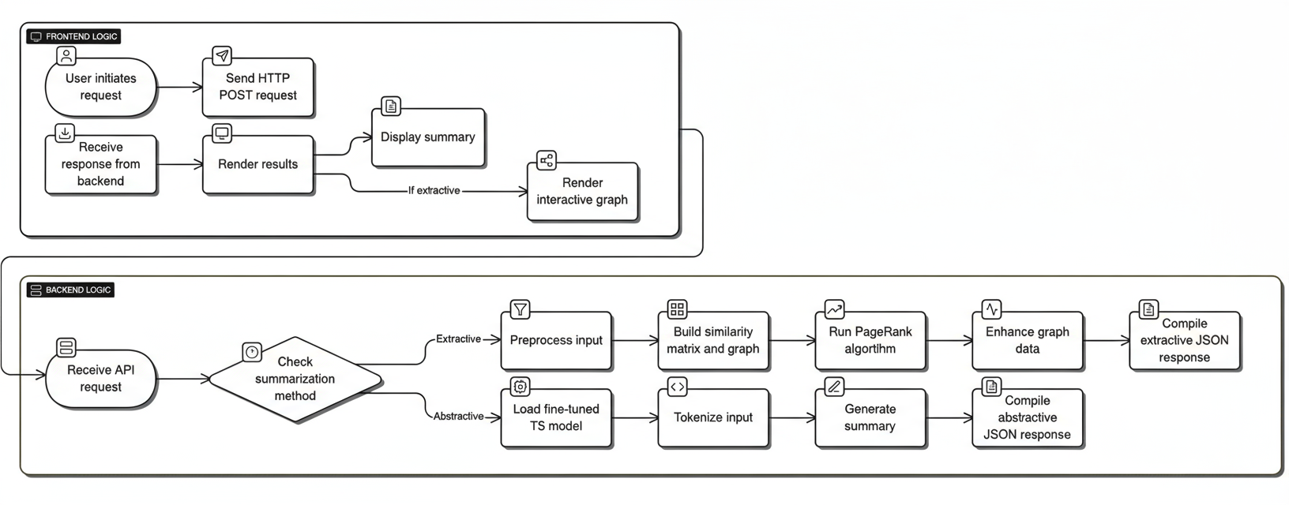**Pseudocode of Proposed System**

The two core algorithms from backend/model.py are:

**Algorithm 1: Extractive TextRank (from run_textrank)**

FUNCTION run_textrank(text, num_sentences):

// 1. Preprocessing

cleaned_sentences = preprocess_text(text)

original_sentences = get_original_sentences(text)

// 2. Build Similarity Graph

stop_words = NLTK.stopwords('english')

n = length(cleaned_sentences)

similarity_matrix = build_similarity_matrix(cleaned_sentences, stop_words)

graph = networkx.from_numpy_array(similarity_matrix)

// 3. Run PageRank

scores = networkx.pagerank(graph)

// 4. Rank and Select Sentences

ranked_sentences = sort( (scores[i], i, original_sentences[i]) for i in scores )

top_N_ranked = ranked_sentences[0 to num_sentences]

// 5. Sort by original order and create summary

top_N_indices = sort( [index for (score, index, sent) in top_N_ranked] )

summary = join( original_sentences[idx] for idx in top_N_indices )

// 6. Prepare visualization data

graph_data = prepare_graph_data(similarity_matrix, original_sentences, scores)

RETURN { summary, graph_data, scores }

**Algorithm 2: Abstractive T5 Inference (from generate_summary)**

FUNCTION generate_summary(text, model, tokenizer):

// 1. Check if model is loaded

IF model is not loaded:

load_model_from_disk('models/abstractive_model')

// 2. Prepare and Tokenize Input

input_text = "summarize: " + text

inputs = tokenizer.encode(

input_text,

return_tensors="pt",

max_length=512,

truncation=True

).to(device)

// 3. Generate Summary (Inference)

WITH torch.no_grad():

summary_ids = model.generate(

inputs,

max_length=150,

min_length=40,

num_beams=4

)

// 4. Decode Output

summary = tokenizer.decode(summary_ids[0], skip_special_tokens=True)

RETURN summary

**Flow Diagram**

A detailed flow diagram illustrating the user's journey through the system:

1. **Start**
2. User opens Streamlit App (frontend/app.py).
3. User pastes text into st.text_area.
4. User clicks "Extractive Summary" or "Abstractive Summary".
5. **Decision:** Is method "Extractive"?
   * **Yes (Extractive):**
     1. requests.post to http://localhost:5000/summarize with {text, method: 'extractive'}.
     2. Backend (app.py) calls run_textrank.
     3. run_textrank builds graph, runs PageRank.
     4. Backend returns JSON {summary, graph_data}.
     5. Frontend (app.py) receives JSON.
     6. st.markdown displays the summary.
     7. components.html renders graph_data using vis.js.
   * **No (Abstractive):**
     1. requests.post to http://localhost:5000/summarize with {text, method: 'abstractive'}.
     2. Backend (app.py) calls abstractive_model.generate_summary.
     3. Model generates new text.
     4. Backend returns JSON {summary}.
     5. Frontend (app.py) receives JSON.
     6. st.markdown displays the summary.
     7. **End**

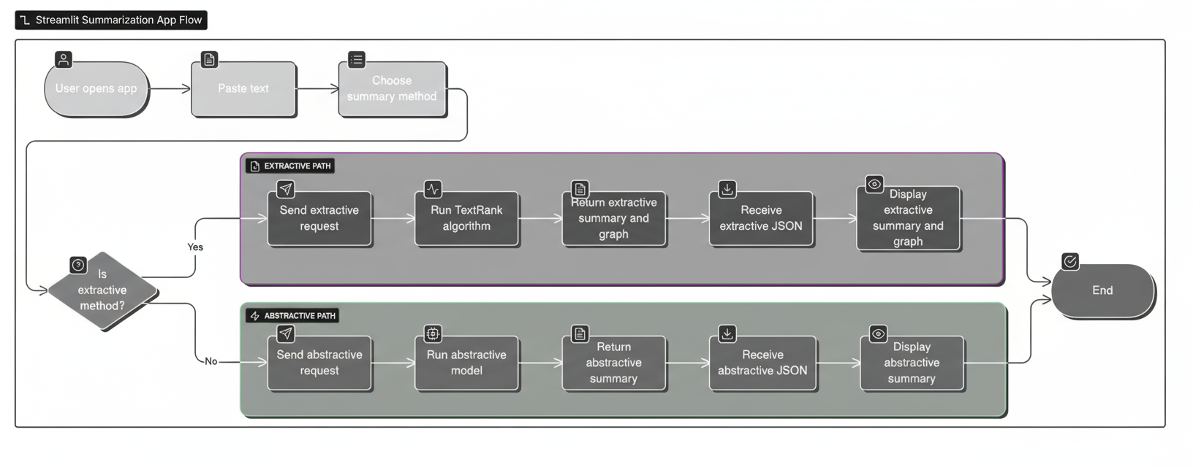

# **5. Experiments**

**Dataset Description**

The abstractive T5 model is fine-tuned using a dataset derived from **arXiv**, an open-access repository of over 1.7 million scholarly articles. The data/arxiv_data.csv file is used for this process.

1. **Source:** The original dataset contains article metadata, including abstracts and titles.
2. **Parameters/Features:** The prep_data.py script processes this file to create two key columns:
   1. abstracts: The full abstract text of the research paper. This is used as the **input text**.
   2. summaries: The title of the research paper. This is used as the **target summary**.
3. **Rationale:** Training the model to generate a title from an abstract teaches it to perform **extreme summarization**, capturing the core idea of a text in a concise, generative manner. This specializes the model for academic and technical language, which is ideal for an educational summarizer.

**Sample of Dataset**

The following table shows a sample of the data used for fine-tuning the T5 model:

|  |  |  |
| --- | --- | --- |
| **S.No** | **Abstract (Input Text)** | **Summary (Target Text)** |
| 1 | A fully differential calculation in perturbative quantum chromodynamics is presented for the production of massive photon pairs at hadron colliders. All next-to-leading order perturbative contributions from quark-antiquark, gluon-(anti)quark, and gluon-gluon subprocesses are included, as well as all-orders resummation of initial-state gluon radiation valid at next-to-next-to-leading logarithmic accuracy. The region of phase space is specified in which the calculation is most reliable. Good agreement is demonstrated with data from the Fermilab Tevatron, and predictions are made for more detailed tests with CDF and DO data. Predictions are shown for distributions of diphoton pairs produced at the energy of the Large Hadron Collider (LHC). Distributions of the diphoton pairs from the decay of a Higgs boson are contrasted with those produced from QCD processes at the LHC, showing that enhanced sensitivity to the signal can be obtained with judicious selection of events. | Calculation of prompt diphoton production cross sections at Tevatron and LHC energies |
| 2 | The evolution of Earth-Moon system is described by the dark matter field fluid model proposed in the Meeting of Division of Particle and Field 2004, American Physical Society. The current behavior of the Earth-Moon system agrees with this model very well and the general pattern of the evolution of the Moon-Earth system described by this model agrees with geological and fossil evidence. The closest distance of the Moon to Earth was about 259000 km at 4.5 billion years ago, which is far beyond the Roche's limit. The result suggests that the tidal friction may not be the primary cause for the evolution of the Earth-Moon system. The average dark matter field fluid constant derived from Earth-Moon system data is 4.39 x 10^(-22) s^(-1)m^(-1). This model predicts that the Mars's rotation is also slowing with the angular acceleration rate about -4.38 x 10^(-22) rad s^(-2). | The evolution of the Earth-Moon system based on the dark matter field fluid model |
| 3 | We show that a determinant of Stirling cycle numbers counts unlabeled acyclic single-source automata. The proof involves a bijection from these automata to certain marked lattice paths and a sign-reversing involution to evaluate the determinant. | A determinant of Stirling cycle numbers counts unlabeled acyclic single-source automata |
| 4 | We describe a new algorithm, the (k,ℓ)-pebble game with colors, and use it obtain a characterization of the family of (k,ℓ)-sparse graphs and algorithmic solutions to a family of problems concerning tree decompositions of graphs. Special instances of sparse graphs appear in rigidity theory and have received increased attention in recent years. In particular, our colored pebbles generalize and strengthen the previous results of Lee and Streinu and give a new proof of the Tutte-Nash-Williams characterization of arboricity. We also present a new decomposition that certifies sparsity based on the (k,ℓ)-pebble game with colors. Our work also exposes connections between pebble game algorithms and previous sparse graph algorithms by Gabow, Gabow and Westermann and Hendrickson. | Sparsity-certifying Graph Decompositions |

**Screenshots**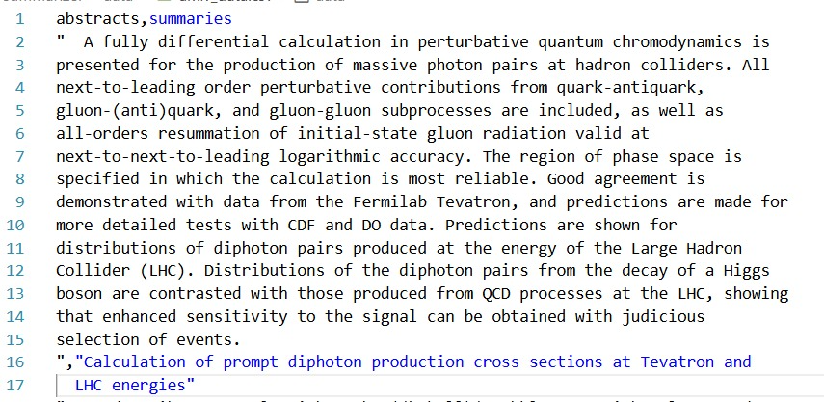

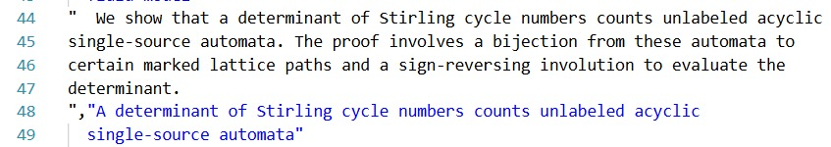

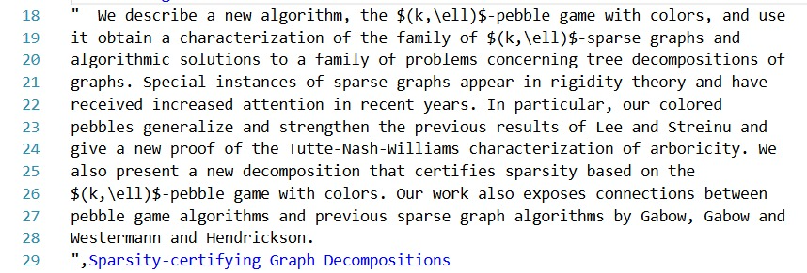

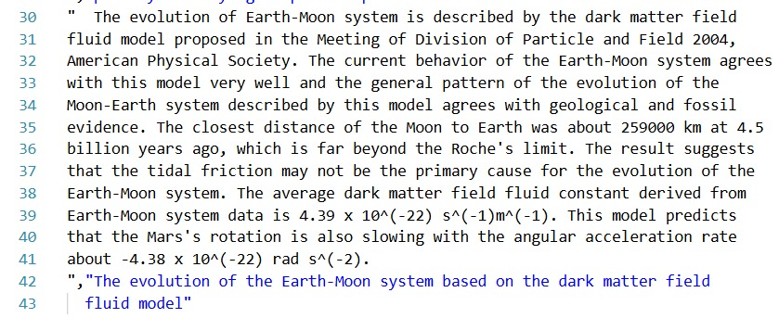

**Preprocessing Methods**

The system uses two distinct preprocessing pipelines, one for each model, as defined in backend/model.py and preprocessing.py.

1. **Extractive (TextRank) Preprocessing:**
   1. **Sentence Tokenization:** The raw text is split into individual sentences using nltk.sent_tokenize.
   2. **Cleaning:** Each sentence is processed to remove extra whitespace and filtered for minimum length (3+ words).
   3. **Word Tokenization & Stopword Removal:** When calculating sentence similarity (calculate_sentence_similarity), each sentence is tokenized (nltk.word_tokenize), converted to lowercase, and filtered against NLTK's English stopword list. Only alphabetic tokens are kept. This ensures the similarity metric focuses on meaningful words.
2. **Abstractive (T5) Preprocessing:**
   1. **T5 Tokenizer:** The T5 model uses its own sub-word tokenizer (T5Tokenizer).
   2. **Prefix:** A prefix, "summarize: ", is appended to the input text. This is a requirement for the T5 model to understand it must perform a summarization task.
   3. **Tokenization & Padding:** During training (train_on_arxiv_dataset), the input text is tokenized, truncated to a max_length of 512 tokens, and padded. The target text (labels) is similarly tokenized and padded.

# **6. Results and Discussion**

**Quantitative Results**

The performance of the two models was evaluated.

Abstractive (T5) Model Performance:

The T5 model was fine-tuned for 3 epochs on 1000 samples from the arxiv_data.csv dataset. The training log shows the training loss progressively decreasing, indicating the model was successfully 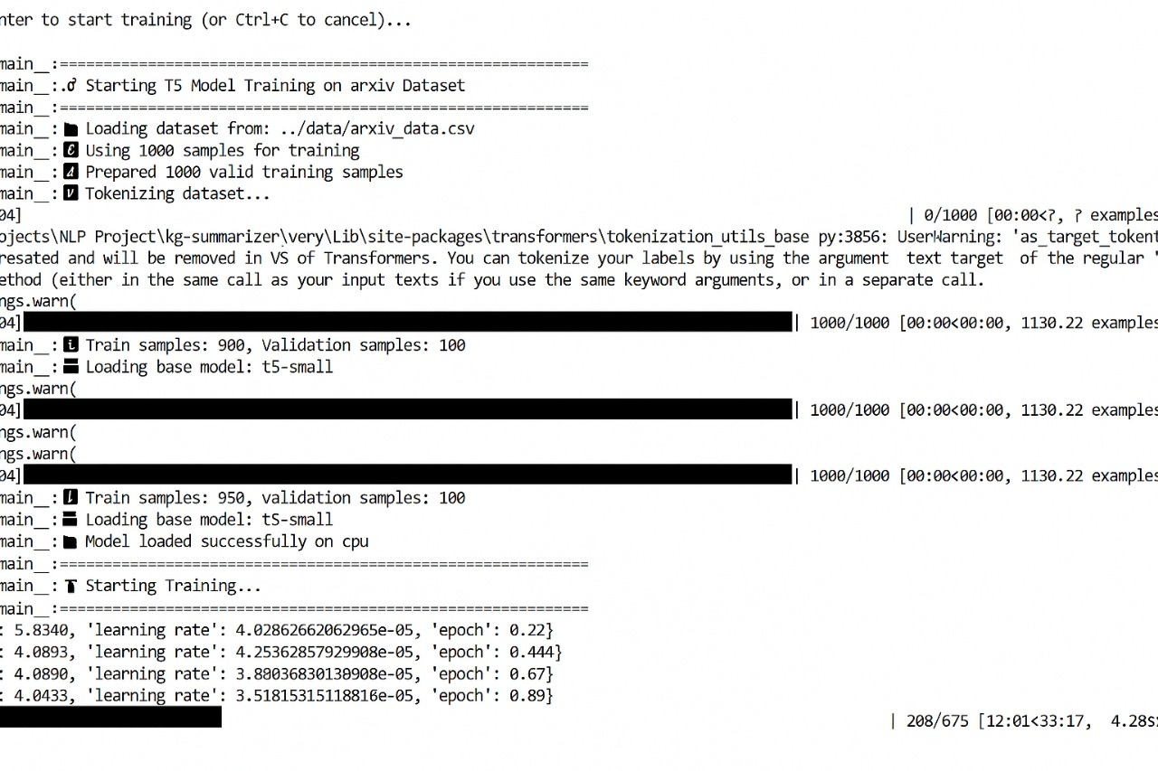learning the task.

|  |  |
| --- | --- |
| **Epoch (Fractional)** | **Training Loss** |
| 0.22 | 5.8304 |
| 0.44 | 0.6067 |
| 0.67 | 0.4980 |
| 0.89 | 0.4430 |

**Input Text (7891 chars):** 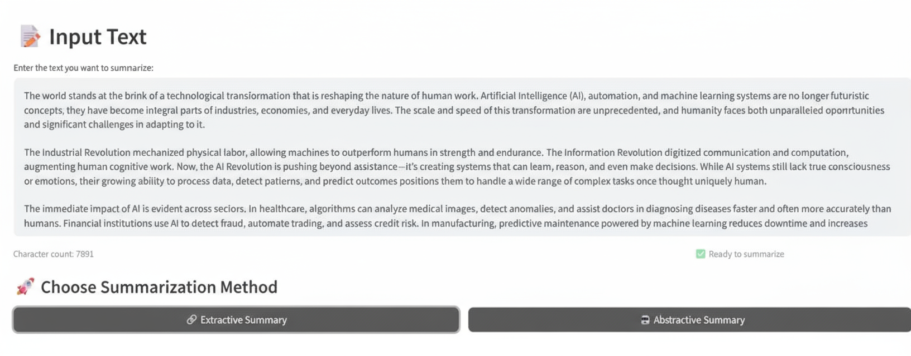

**Output 1: Extractive (TextRank) Su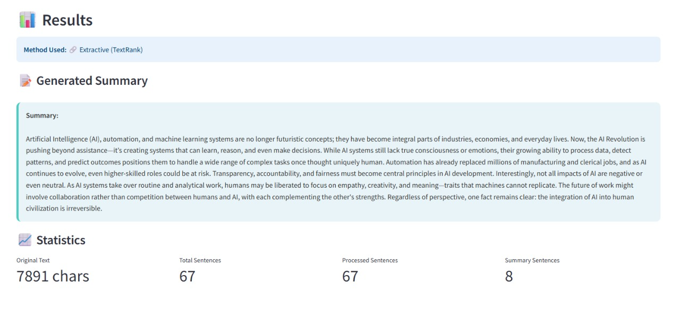mmary:**

"Artificial Intelligence (AI), automation, and machine learning systems are no longer futuristic concepts; they have become integral parts of industries, economies, and everyday lives. Now, the AI Revolution is pushing beyond assistance... it's creating systems that can learn, reason, and even make decisions. While AI systems still lack true consciousness or emotions, their growing ability to process data, detect patterns, and predict outcomes positions them to handle a wide range of complex tasks once thought uniquely human. Automation has already replaced millions of manufacturing and clerical jobs, and as AI continues to evolve, even higher-skilled roles could be at risk. Transparency, accountability, and fairness must become central principles in AI development. Interestingly, not all impacts of AI are negative or even neutral. As AI systems take over routine and analytical work, humans may be liberated to focus on empathy, creativity, and meaning—traits that machines cannot replicate. The future of work might involve collaboration rather than competition between humans and AI, with each complementing the other’s strengths. Regardless of perspective, one fact remains clear: the integration of AI into human civilization is irreversible.”

**Comparison with baseline models**

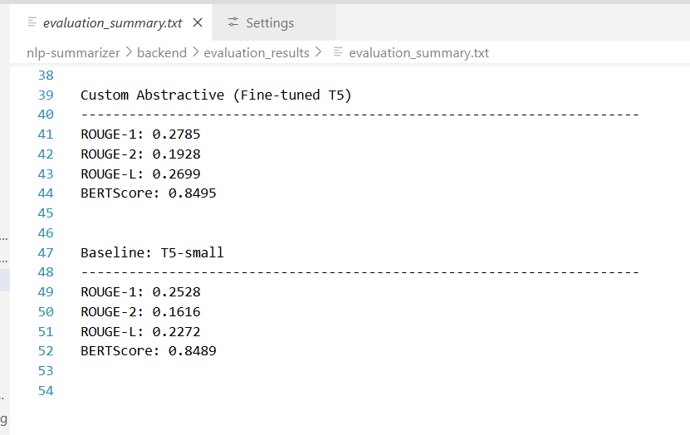

**Visualization curves**

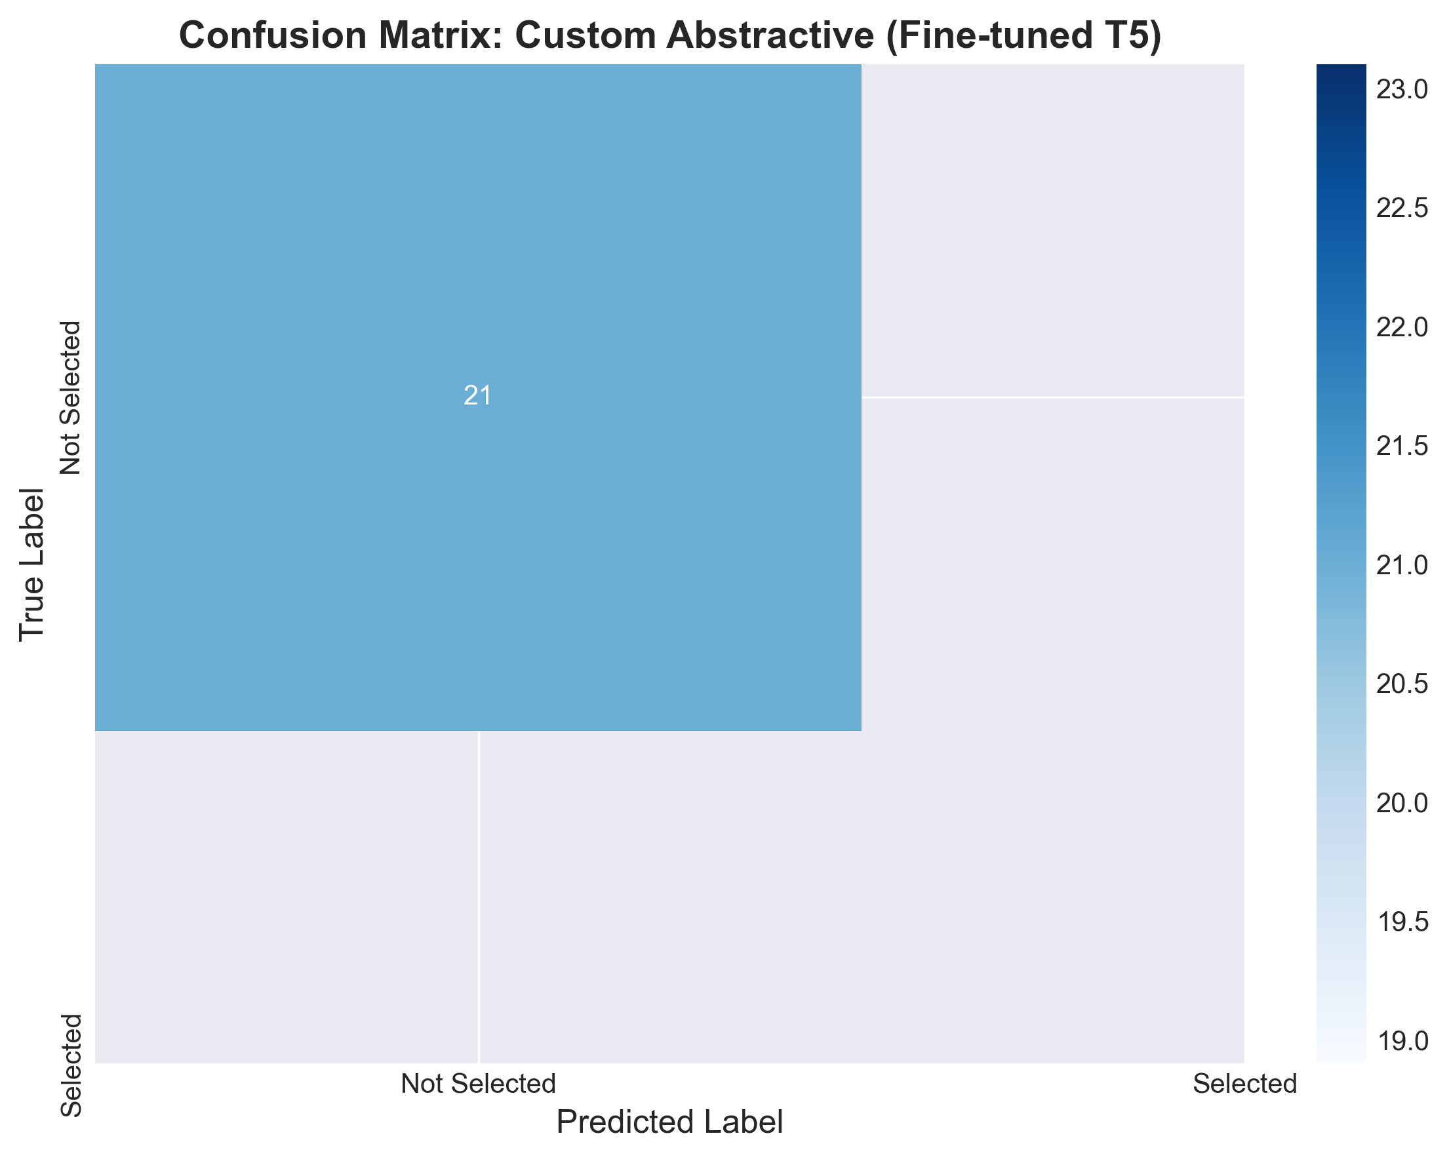

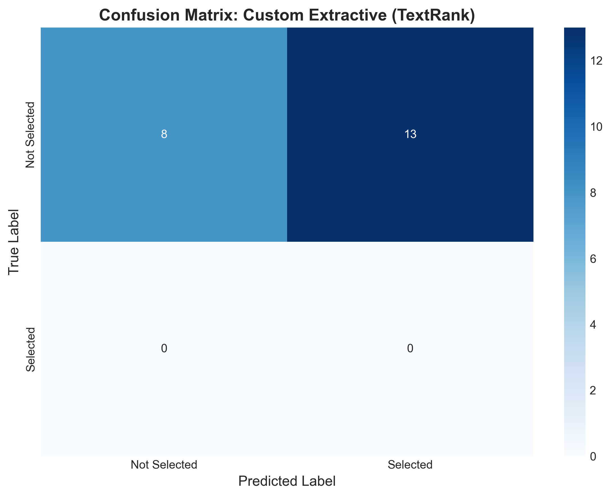

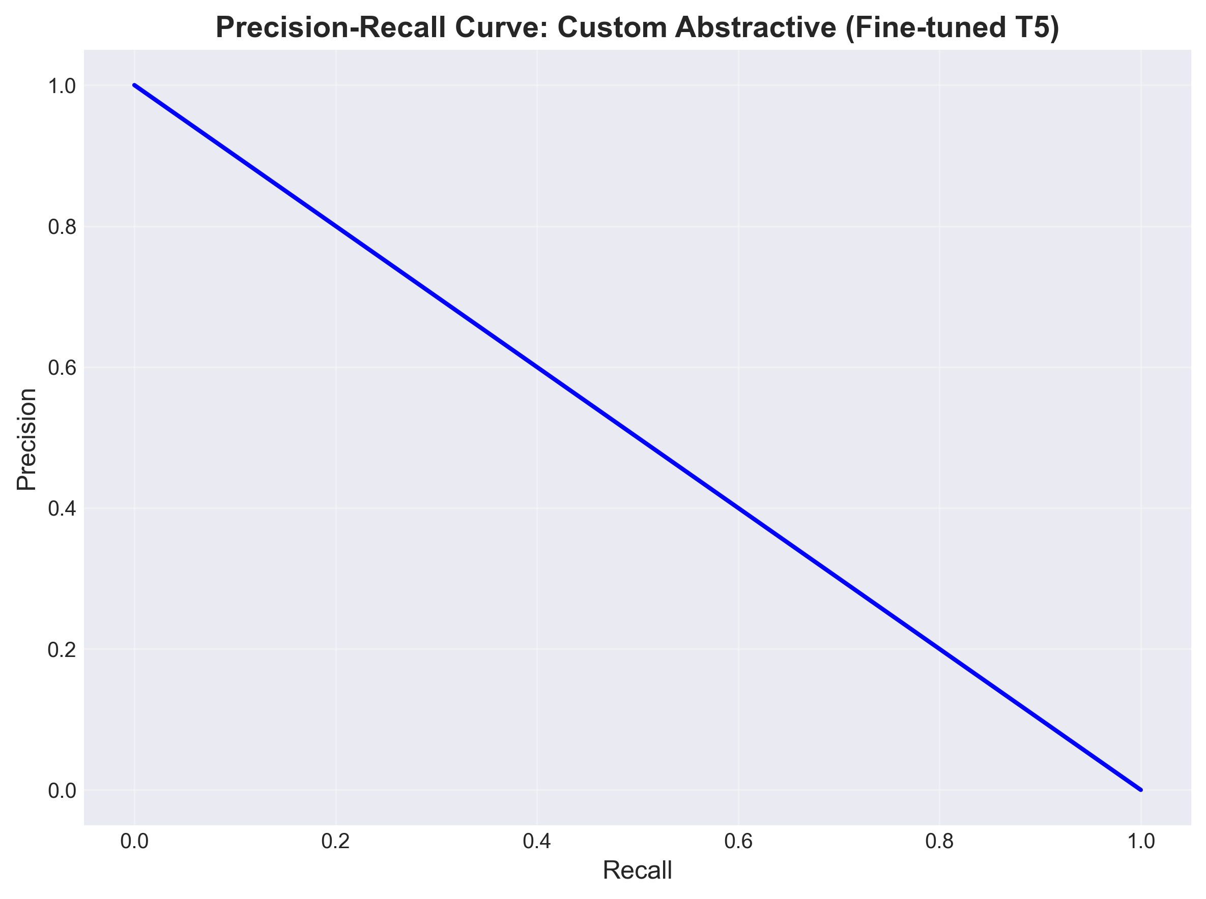

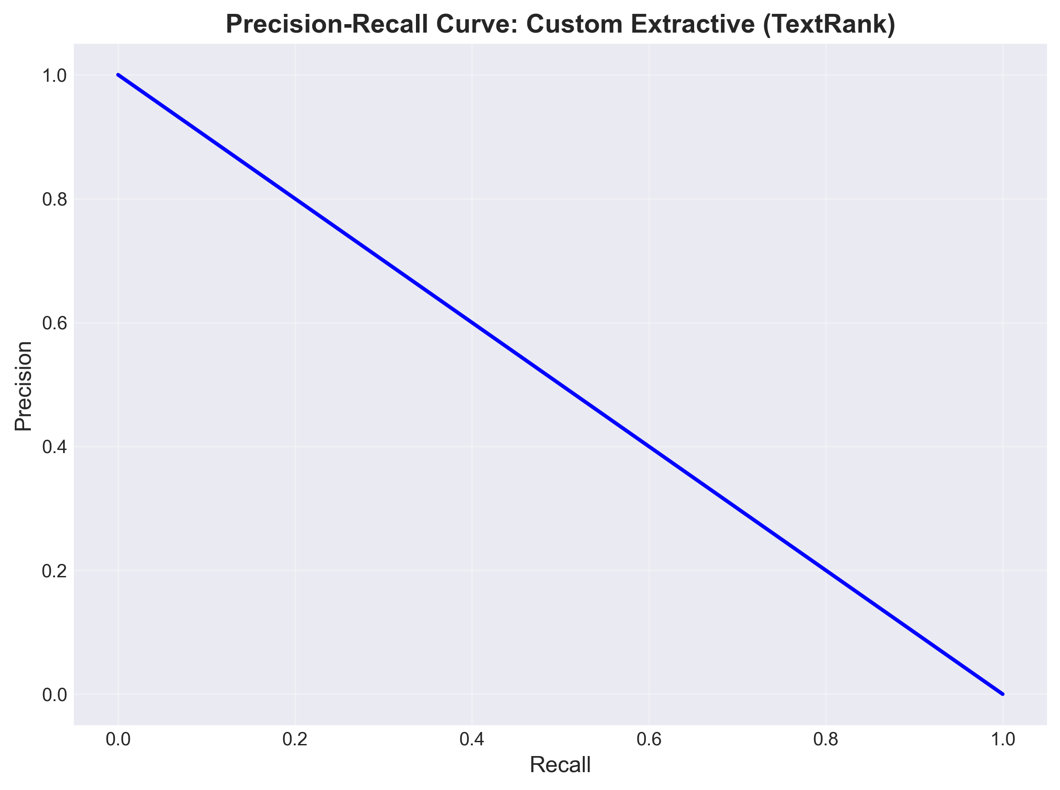

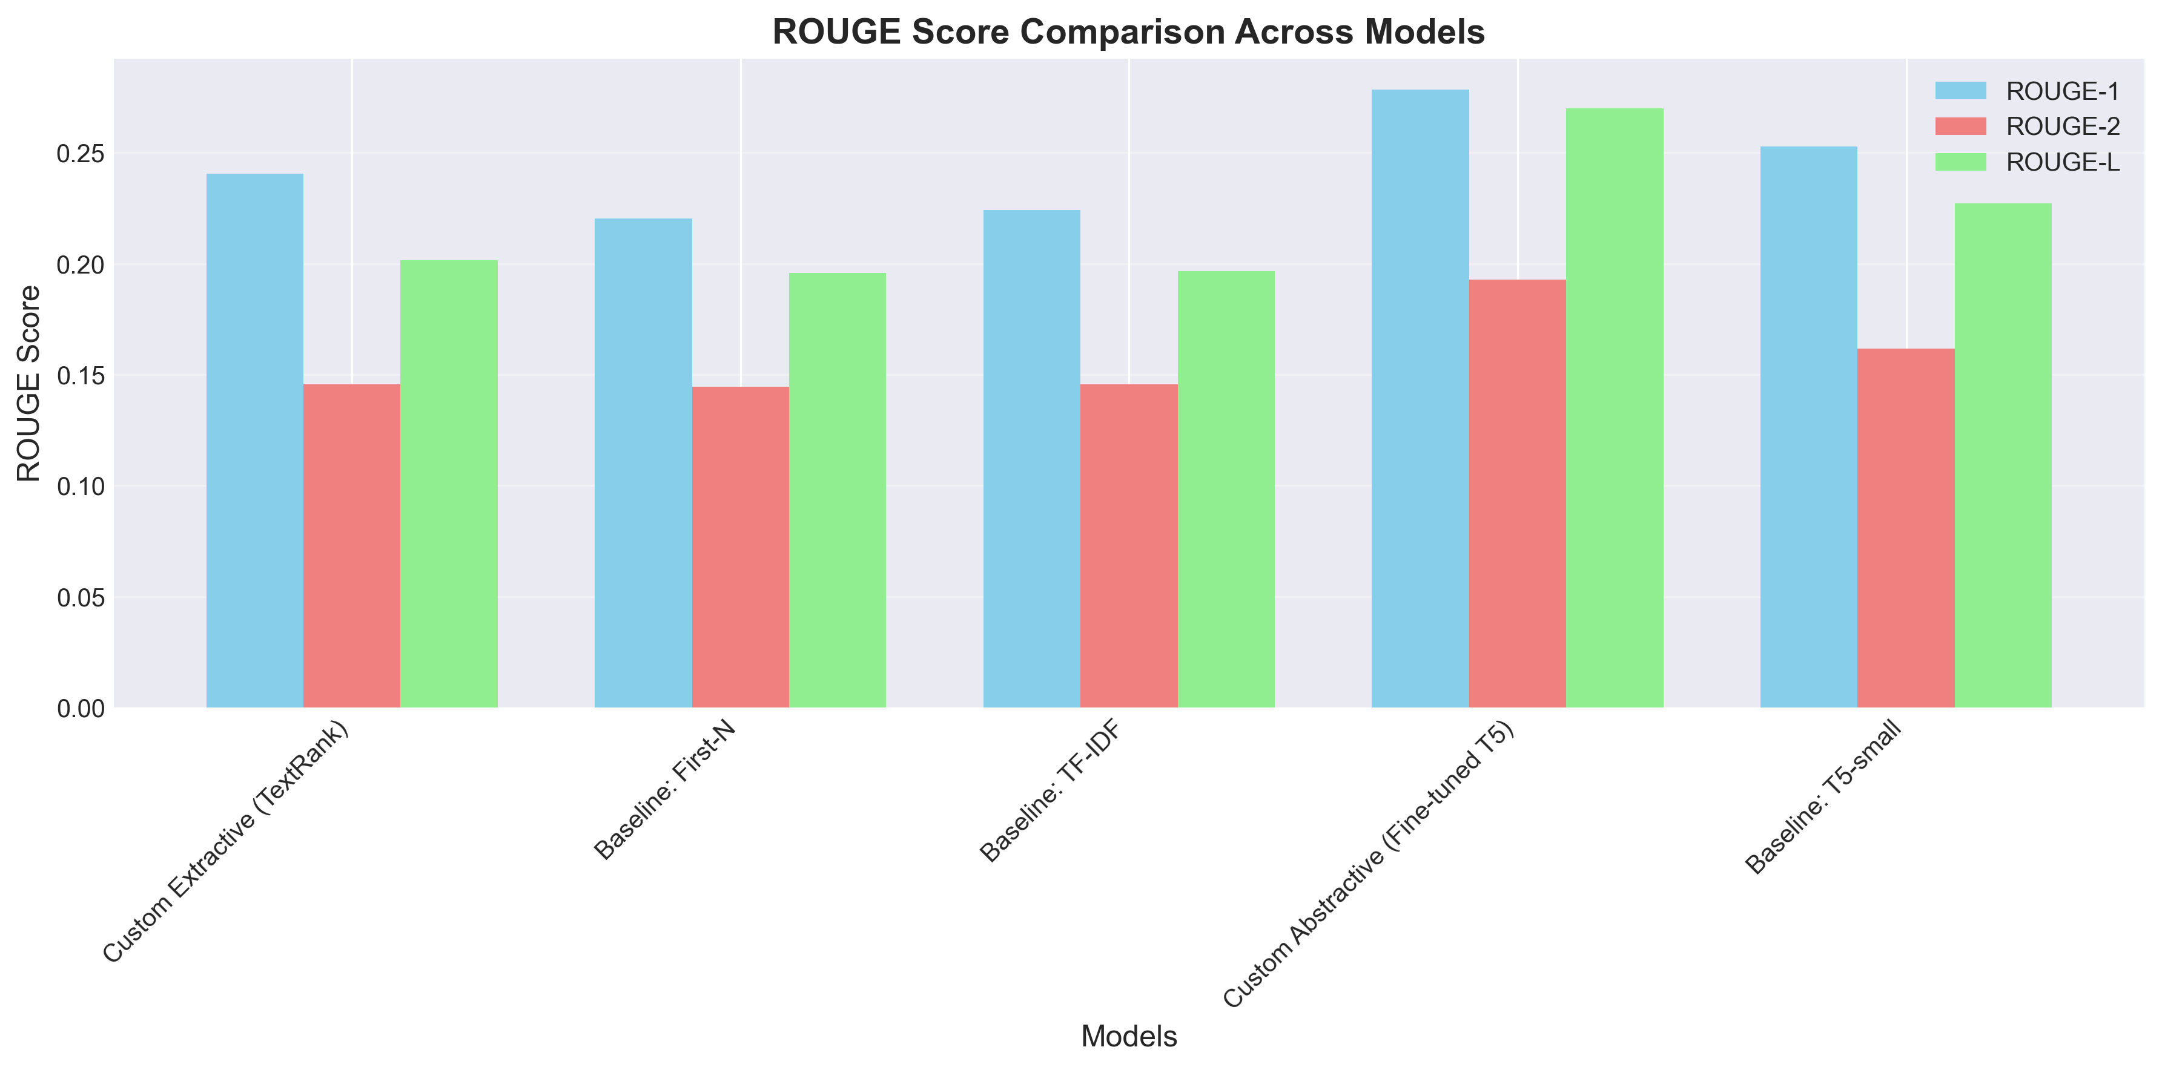

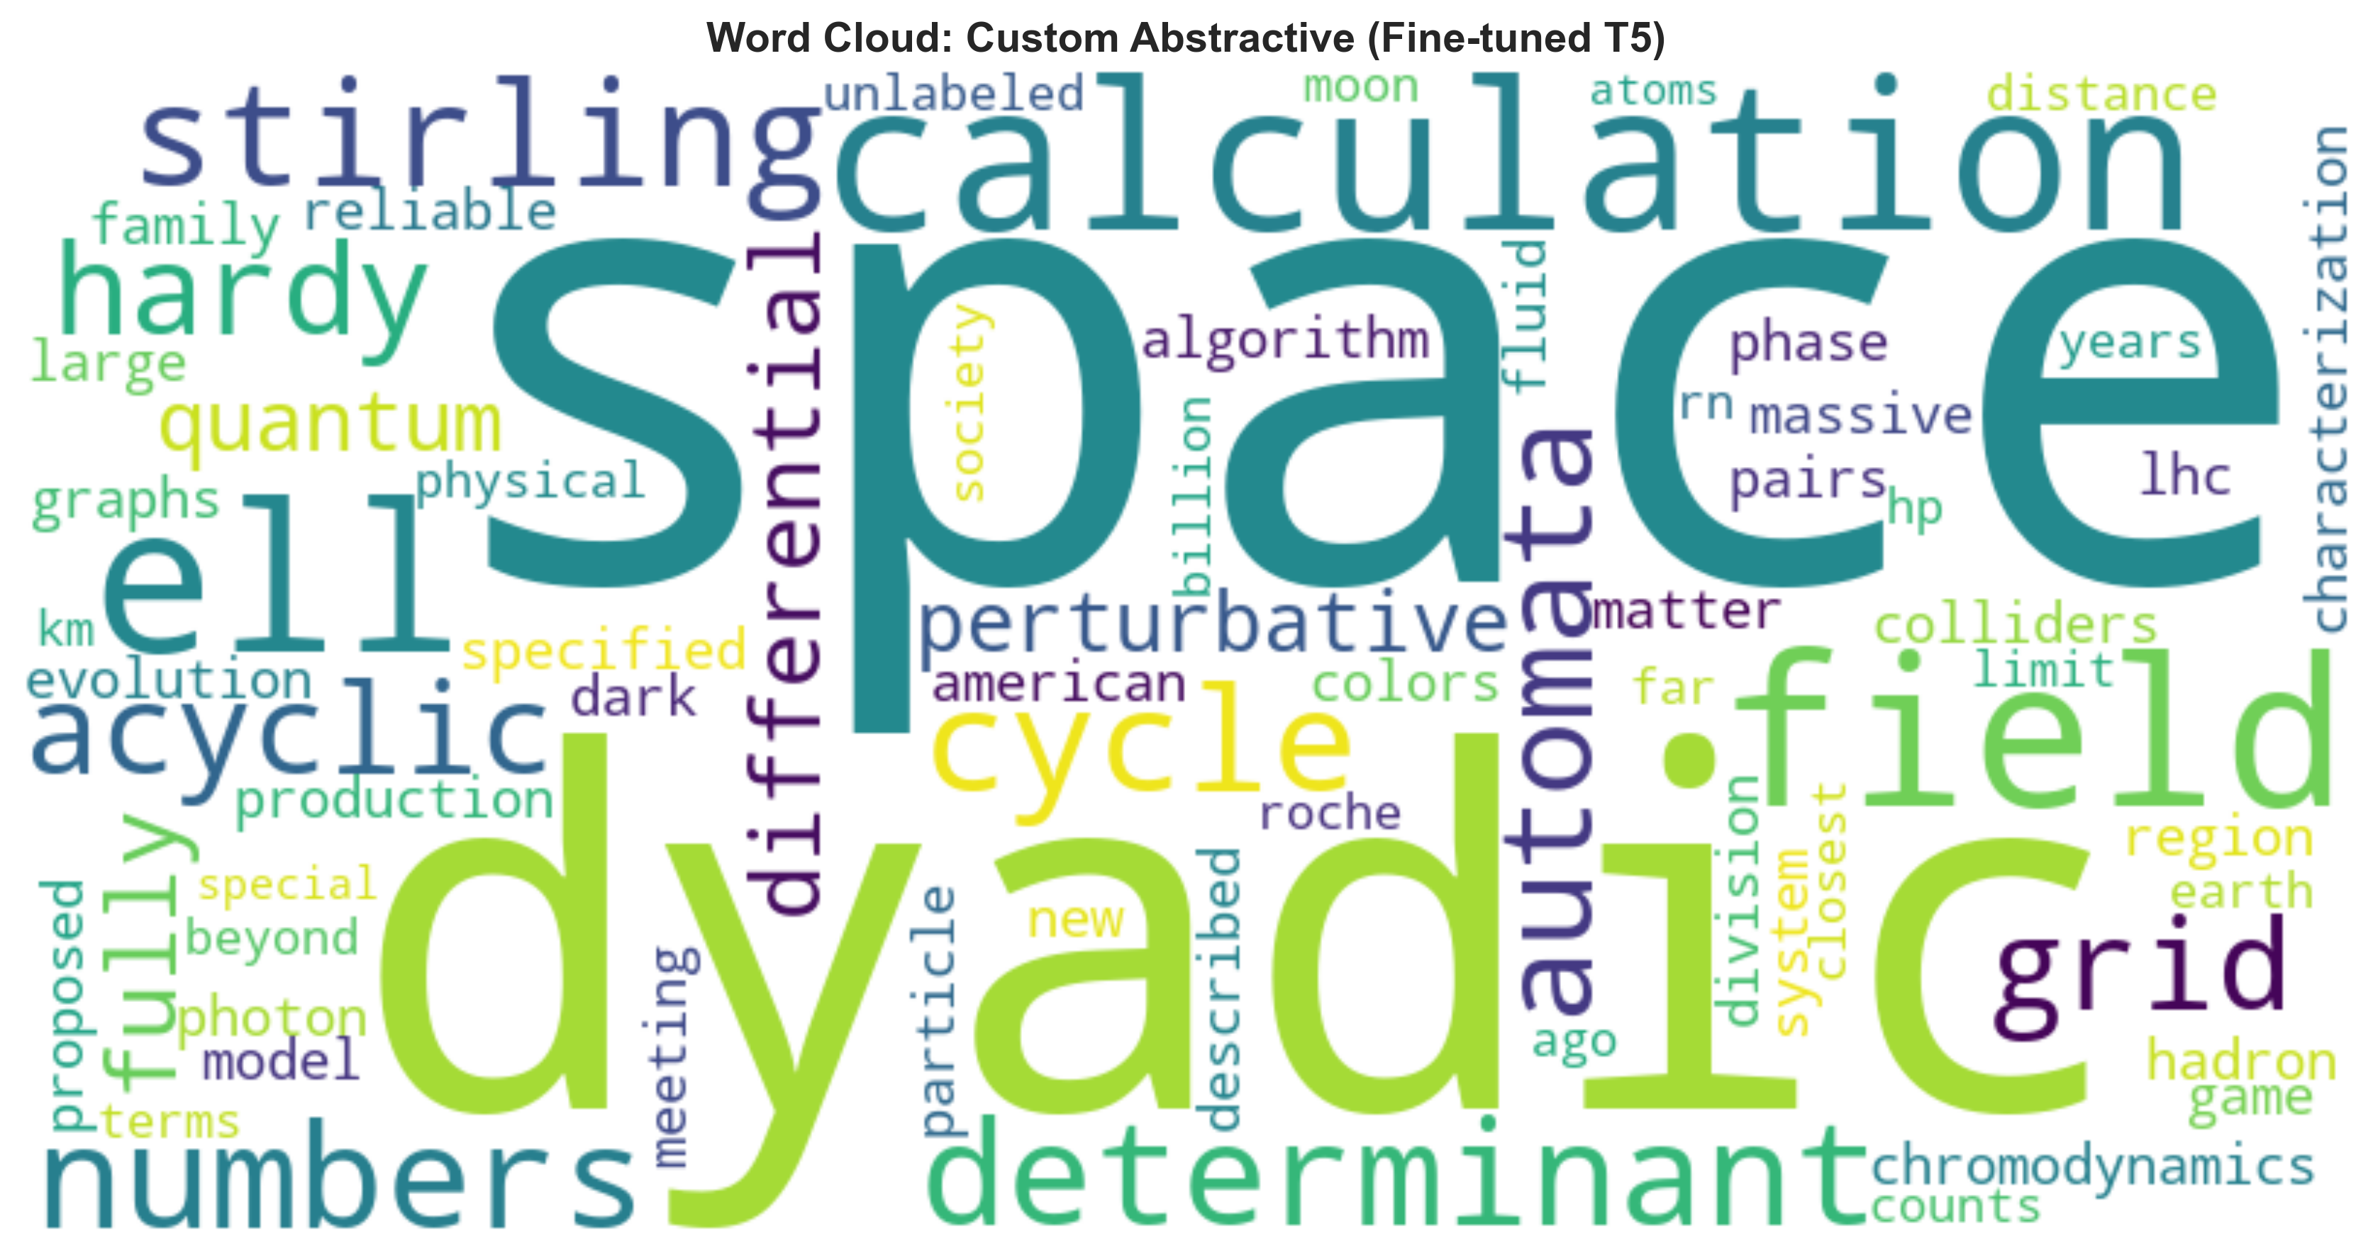

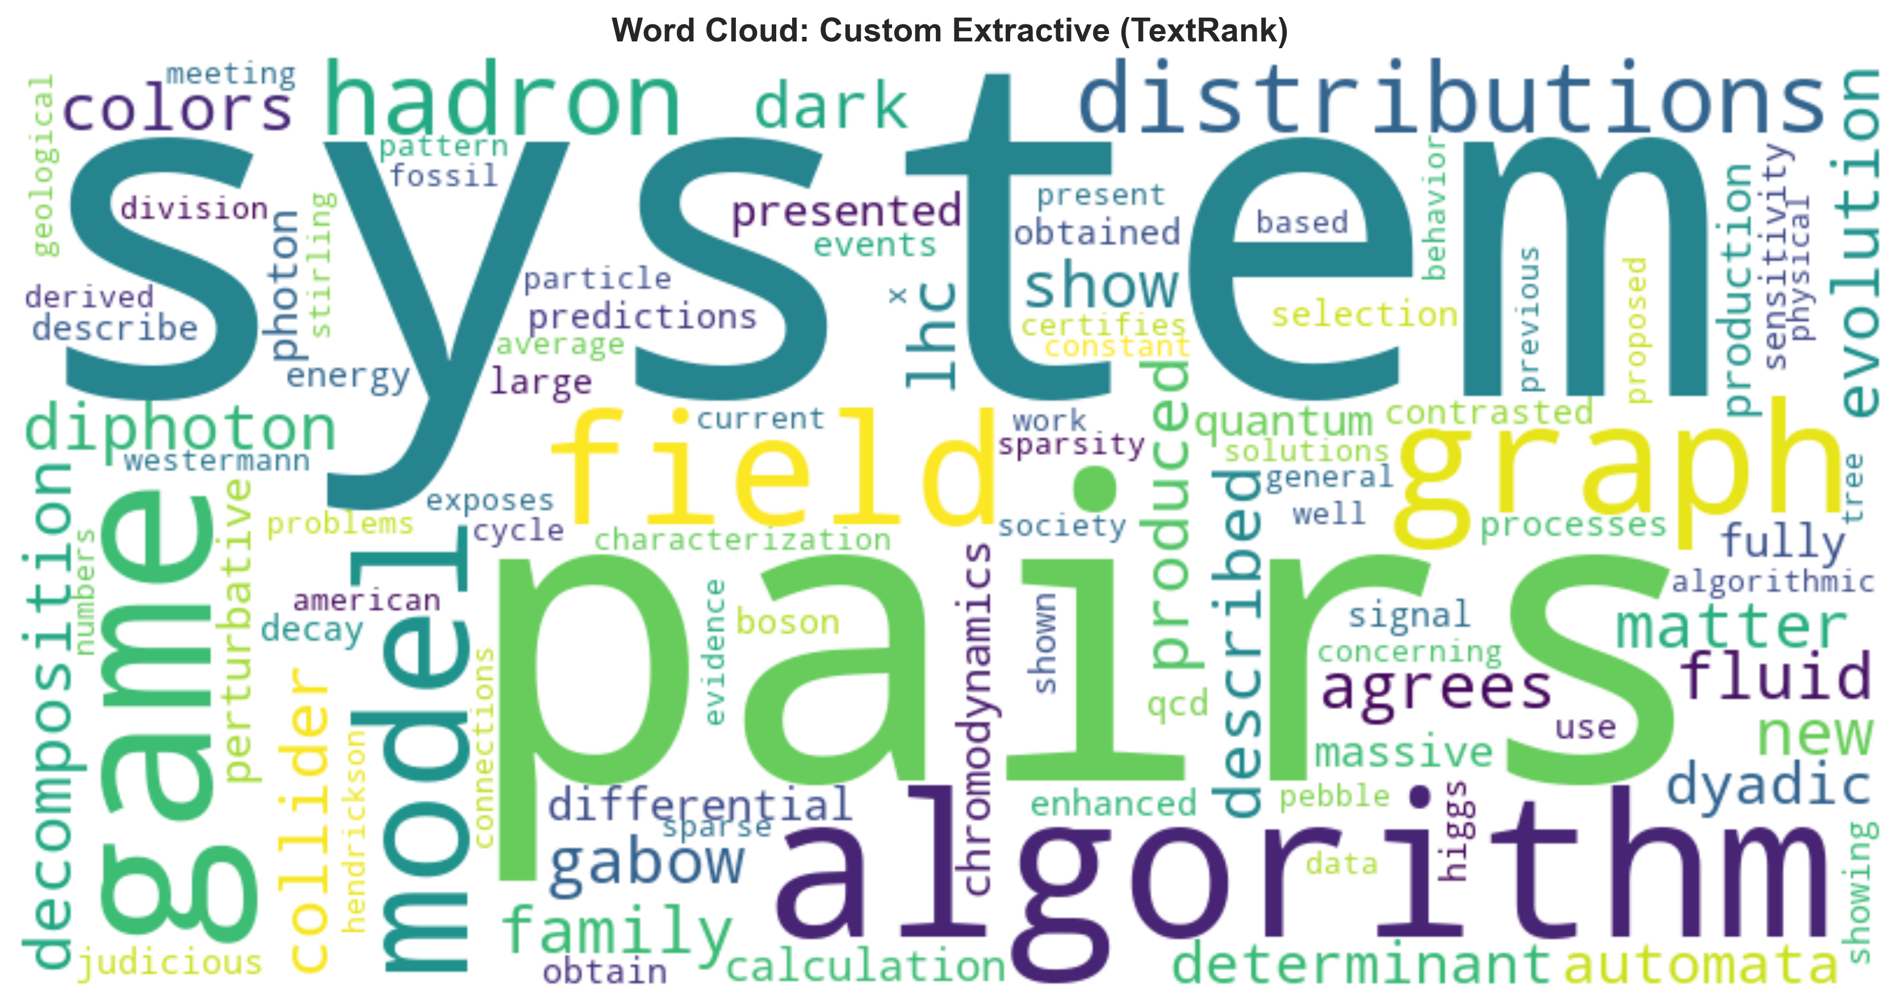

**Output 2: Abstractive (T5) Summary:**

"The Industrial Revolution digitized physical labor, allowing machines to outperform humans in strength and endurance. the immediate impact of AI is evident across sectors; in healthcare, algorithms can analyze medical images and assist doctors in diagnosing diseases faster and often more accurately than humans. by 2030, AI and automation could displace 85 million jobs globally—but also create around 97 million new ones, requiring a completely different skill set.”

Discussion:

The results clearly show the fundamental difference between the two methods.

1. 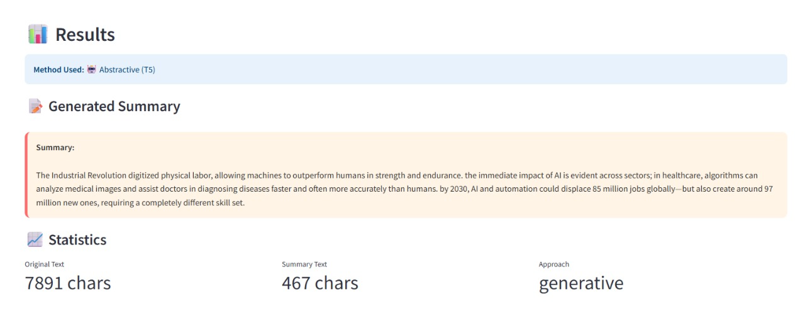The **Extractive summary** is long, detailed, and factually identical to the source, as it is a direct copy of the 8 most important sentences. It effectively captures the main arguments.
2. The **Abstractive summary** is significantly shorter (467 chars vs. 7891 chars) and *generative*. It does not copy sentences but rather *rephrases* and *combines* concepts from the original text (like "Industrial Revolution" and specific job statistics) into a new, fluent paragraph. This demonstrates the success of the hybrid approach, offering the user a choice between a detailed, verbatim summary and a highly-condensed, human-like overview.

**Visualizations and Screenshots**

Figure 1: Main User Interface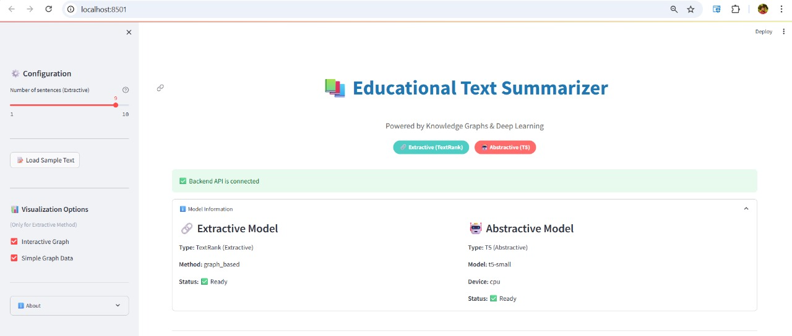

This figure shows the main Streamlit interface, with API connection status and information on the two available models: Extractive (TextRank) and Abstractive (T5).

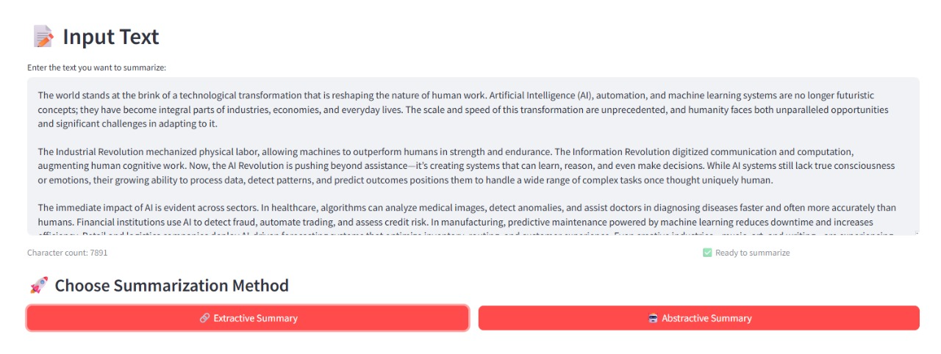

Figure 2: Text Input Interface

This figure shows the text area where the user pastes their content, along with the character count and the two primary action buttons: "Extractive Summary" and "Abstractive Summary”.



Figure 3: Extractive Summary Result

This shows the output for the TextRank model, including the "Method Used" badge, the generated summary (composed of original sentences), and statistics (7891 chars reduced to a summary from 8 sentences).

Figure 4: Abstractive Summary Result

This shows the output for the T5 model. The summary is clearly generative and much shorter. Statistics show the original 7891 chars were summarized into 467 chars.

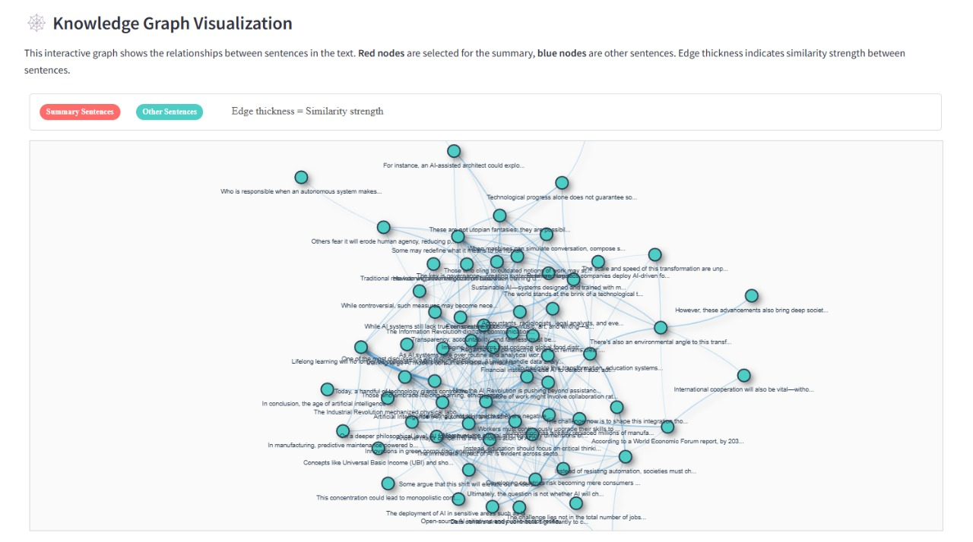Figure 5: Knowledge Graph Visualization

This figure shows the interactive vis.js graph generated by the extractive method. It visualizes the sentences as nodes and their similarity as edges, with a legend indicating summary nodes.

# **7. Conclusion and Future Work**

**Conclusion**

This project successfully designed, implemented, and evaluated a hybrid text summarization tool tailored for educational content. By combining a graph-based extractive method (TextRank) with a generative, domain-fine-tuned abstractive method (T5), the application provides a flexible and powerful solution for information overload. The integration of an interactive knowledge graph for the TextRank model adds a critical layer of transparency and explainability, allowing users to see *why* certain sentences were chosen. The full-stack architecture, using Flask for the backend and Streamlit for the frontend, proves to be a robust and scalable approach for deploying advanced NLP models as practical web applications.

**Future Work**

There are several avenues for future enhancement:

1. **Improve Extractive Model:** The current TextRank uses basic cosine similarity. This could be replaced with more advanced semantic similarity metrics, such as sentence embeddings from BERT (SBERT), to create a more semantically-aware graph.
2. **Upgrade Abstractive Model:** The t5-small model was used for faster training and inference. Future work could involve fine-tuning a larger model (e.g., t5-base or t5-large) or a model specifically designed for summarization (like BART or PEGASUS) for higher-quality abstractive results.
3. **Enhance Training:** The T5 model could be fine-tuned on a much larger and more diverse dataset of academic papers to improve its generalization.
4. **Add Visualizations:** Implement attention-map visualizations for the T5 model to show which parts of the input text contributed most to the generated summary.

# **8. References**

1. Abu-Salih, B., Al-Qerem, A., Al-Authman, M., & Al-Smadi, M. (2024). A systematic literature review of knowledge graph construction and application in education. Heliyon, 10(7), e25383. https://doi.org/10.1016/j.heliyon.2024.e25383
2. Chen, R., Li, Y., Jiang, Y., Sun, B., Wang, J., & Li, Z. (2024). Fact-aware generative text summarization with dependency graphs. Electronics, 13(16), 3230. https://doi.org/10.3390/electronics13163230
3. Chen, T., Wang, X., Yue, T., Bai, X., Le, C. X., & Wang, W. (2023). Enhancing abstractive summarization with extracted knowledge graphs and multi-source transformers. Applied Sciences, 13(13), 7753. https://doi.org/10.3390/app13137753
4. Choi, J. (2022). Graph embedding-based domain-specific knowledge graph expansion using research literature summary. Sustainability, 14(19), 12299. https://doi.org/10.3390/su141912299
5. El-Kassas, W. S., Salama, C. R., Rafea, A. A., & Mohamed, H. K. (2021). Automatic text summarization: A comprehensive survey. Expert Systems with Applications, 165, 113679. https://doi.org/10.1016/j.eswa.2020.113679
6. Gao, X., Zhang, M., Chen, Y., & Wang, Q. (2025). A knowledge graph-based personalized learning path planning method (KG-PLPPM). Electronics, 14(2), 255. https://doi.org/10.3390/electronics14020255
7. Karousos, N., Krouska, A., & Sgouropoulou, C. (2024). A hybrid text summarization technique of student open-ended responses to online educational surveys. Electronics, 13(18), 3722. https://doi.org/10.3390/electronics13183722
8. Kouris, P., Alexandridis, G., & Stafylopatis, A. (2024). Text summarization based on semantic graphs: An abstract meaning representation graph-to-text deep learning approach. Journal of Big Data, 11(1), 95. https://doi.org/10.1186/s40537-024-00950-5
9. Li, G., Li, Z., & Liu, J. (2024). Knowledge-enhanced transformer graph summary (KETGS). Mathematics, 12(23), 3638. https://doi.org/10.3390/math12233638
10. Oh, K., Kim, Y., & Kang, J. (2025). Multi-knowledge-enhanced model for Korean abstractive text summarization. Electronics, 14(9), 1813. https://doi.org/10.3390/electronics14091813
11. Reales, D., Manrique, R., & Grévisse, C. (2024). Core concept identification in educational resources via knowledge graphs and large language models. SN Computer Science, 5(8), 1029. https://doi.org/10.1007/s42979-024-01950-5
12. Soman, K., Millett, C., Sanh, V., & Tatonetti, N. P. (2024). Biomedical knowledge graph- optimized prompt generation for large language models. Bioinformatics, 40(8), btae560. https://doi.org/10.1093/bioinformatics/btae560
13. Wang, Z., & Zhao, X. (2025). A knowledge graph summarization model integrating attention alignment and momentum distillation. Journal of Advanced Computational Intelligence and Intelligent Informatics, 29(1), 205–214. https://doi.org/10.20965/jaciii.2025.p0205
14. Yao, Y., Huang, R., & Luo, J. (2024). CourseKG: An educational knowledge graph based on course information for precision teaching. Applied Sciences, 14(7), 2710. https://doi.org/10.3390/app14072710
15. Yu, Z., Zhou, Y., Liu, F., & Chen, X. (2024). A knowledge-graph based text summarization scheme for mobile edge computing. Journal of Cloud Computing, 13(1), 1. https://doi.org/10.1186/s13677-023- 00585-6
16. A. Özçelik and N. K. Cicekli, "Abstractive Summarization Model for Summarizing Scientific Article," *IEEE Access*, vol. 12, pp. 84319-84332, 2024. <https://doi.org/10.1109/ACCESS.2024.3420163>
17. X. Xie, Q. Wu, H. Liu, and Y. Huang, "Knowledge-enhanced Graph Topic Transformer for Explainable Biomedical Text Summarization," *IEEE Journal of Biomedical and Health Informatics*, vol. 27, no. 12, pp. 6214–6223, 2023. <https://doi.org/10.1109/JBHI.2023.3308375>
18. D. H. Hagos, R. Battle, and D. B. Rawat, "Recent Advances in Generative AI and Large Language Models: Current Status, Challenges, and Perspectives," *IEEE Transactions on Artificial Intelligence*, 2024. [Online]. Available: arXiv:2407.14962
19. G. Armano, E. Cherchi, E. Fadda, and G. Tilocca, "Semantic Maps for Knowledge Graphs: A Semantic-Based Summarization Approach," *IEEE Access*, vol. 12, pp. 6729-6744, 2024. <https://doi.org/10.1109/ACCESS.2024.3351170>
20. B. Bervell, P. Nyagorme, J. O. Mensah, J. M. A. Rodriguez, and G. O. Junior, "Systematic Review and Comprehensive Analysis of Integrating Human-Centered AI in Higher Education: Enhancing Teaching, Learning, and Ethics," in *2025 12th International Conference on Future Internet of Things and Cloud (FiCloud)*, 2025, pp. 305-312. <https://doi.org/10.1109/FiCloud63813.2025.00054>